Invitation to
11th Annual Regatta

Sunday, 11th November 2018
Battle of the Lake

Community Day

Community, Corporate and Junior teams enjoy the thrill of dragon boat racing.
24 teams from businesses, schools and community organisations show us their spirit as they venture onto the water, many of them for the first time.

The Community day will have teams being able to enter in three categories; Junior for school aged teams 10 – 18 years, beginner for the less experienced teams and intermediate.

We are encouraging regional secondary colleges to become involved in this exciting and fun filled sport and support this great community event. Dragon boating requires exceptional team work as every individual works together to move the boat forward and build momentum.

As Sunday 11th 2018 marks the 100th anniversary of the Armistice a Remembrance Ceremony will take place at 11am.

A special Ceremony will be held mid afternoon, to commemorate those we have lost and support.

REGISTRATION
Return completed registration form to regatta@braveheartsonthemurray.com.au
by 19th September 2018

ENTRY FEE PAYMENT
Junior team entry fee is $150.
Individual junior entry fee is $10 per person (non-refundable). Individuals will be grouped into junior teams or fill existing junior teams.
Deposit required by 11th September 2018

Balance due by 11th October 2018
IMPORTANT INFORMATION

Training is required for all teams and individuals:

- First time paddlers – must attend 2 training sessions
- Experienced Paddlers – minimum 1 training session at discretion of Coordinators
Training dates and times to be confirmed and will be forwarded 6 weeks prior to the event.

We can allocate two dragon boat paddlers to your team, if required. Cancer survivors will be invited to participate in the survivors’ ceremony. Crew lists to be submitted on or before the first training day.
Tents welcome but must be secured to the ground. Food, drinks and ice cream available for purchase.
Spectator welcome, BYO chair/rug
Please return the attached entry form to regatta@braveheartsonthemurray.com.au by 11th September 2018. If you cannot email the registration form, please return to the Brave Hearts representative.

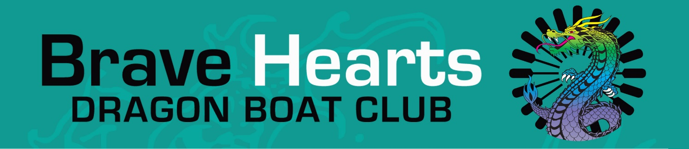
11th Annual Regatta

Sunday, 11th November 2018
Battle of the Lake - Community Day
Gateway Lakes, Lemke Road Wodonga

Team/Individual Name: .......................................................................................

Organisation Name (if applicable): ......................................................................

Team Manager: ..................................................................................................

Email address: ....................................................................................................

Phone: ................................................................................................................

The Community Team Racing Day will have teams competing in two categories. The categories will be decided during the day in consultation with the Team Captain, Sweeps and Head Coach of Brave Hearts.

As well as hosting the event, we will provide all equipment, a qualified sweep to steer the boat and two coaching sessions to teach you how to paddle. Training sessions for all teams and individuals is required with days and times to be confirmed. Please see information sheet.

Team entry fee is $700 per team, with a deposit of $100 (non-refundable). Junior team entry fee is $150.
Individual entry fee is $35 per person (non-refundable). Individuals will be grouped into teams or fill existing teams.

All paddlers will be required to sign a waiver form before entering a boat. This form will be sent after entries have been received.

The number of teams will be limited to a maximum of 28. Places will be allocated as entry forms and deposit payments are received.

Deposit required by 11th September 2018.
Balance due by 11th October 2018

Return completed registration form to
regatta@braveheartsonthemurray.com.au
by 11th Sep 2018

Enquiries to Janine McGrath on 0429 573 625
Brave Hearts on the Murray Inc BSB 633 000 Bendigo Bank
Account No. 162267983 Reference: team name

